**Final Report** **Team** Caitlin Helmer Erika Haren  
 Robert Wood  
 Will Skrab

**Project Title**

Traffic Cameras and Public Safety in the City of Chicago

**Project Description/Outline**

Study of traffic in the City of Chicago, including congestion, crash, and traffic camera data, all of which has been made publicly available by the City of Chicago.

**Questions and Conclusions**

1. In what areas are crashes more/less common?

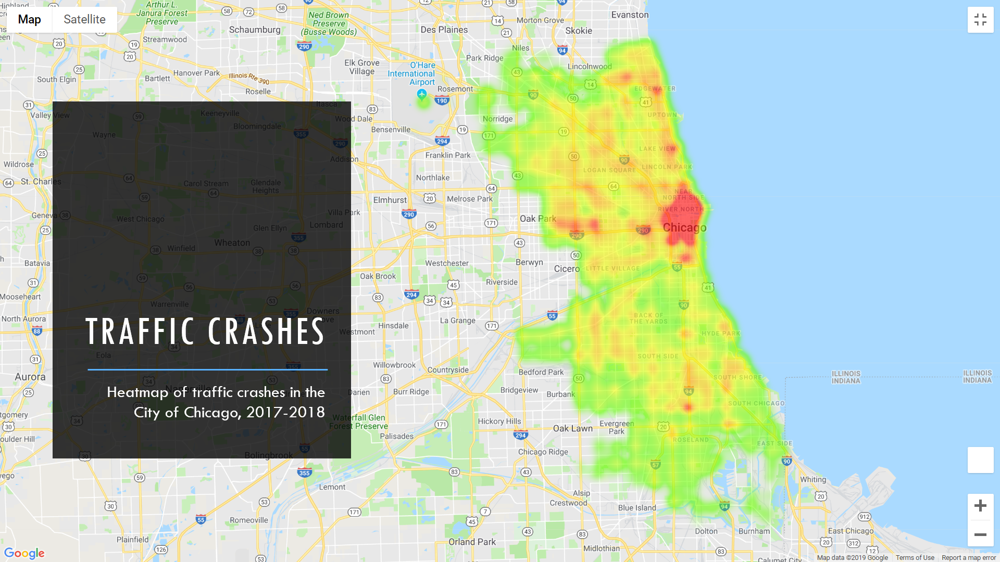

1. Is there a correlation between crashes and red light cameras? Crashes and speed cameras?

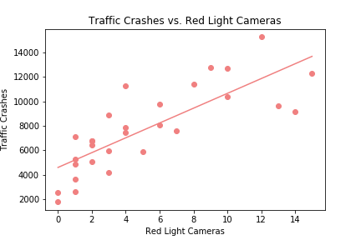

There is a strong correlation between number of red light cameras and crashes

r = 0.80

p = 2.35e-07

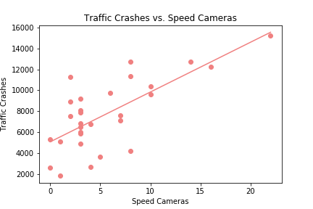

There is a strong correlation between number of speed cameras and crashes

r = 0.71

p = 1.43e-05

Note: Due to lack of available crash data prior to camera installation, not possible to prove causation or effect of camera installation on crash levels

1. What is the average congestion level hour by hour? Does this correlate to the number of crashes?

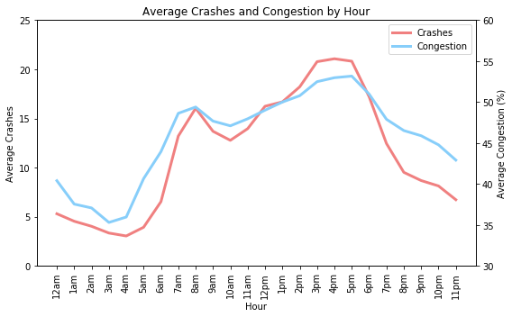

Trend shows higher congestion levels during standard morning and evening commutes, as expected

Extremely strong correlation between congestion and crashes by time of day

r = 0.95

p = 6.15e-13

1. In what areas are drunk-driving accidents more/less common?

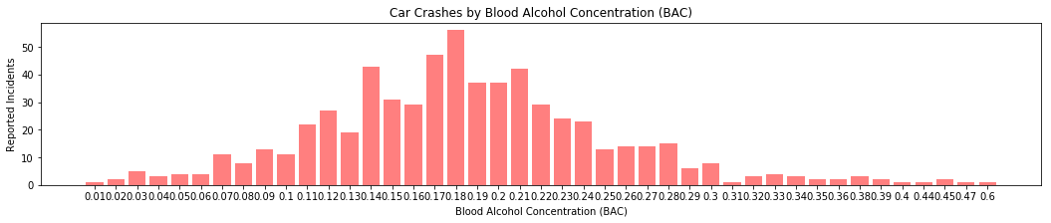

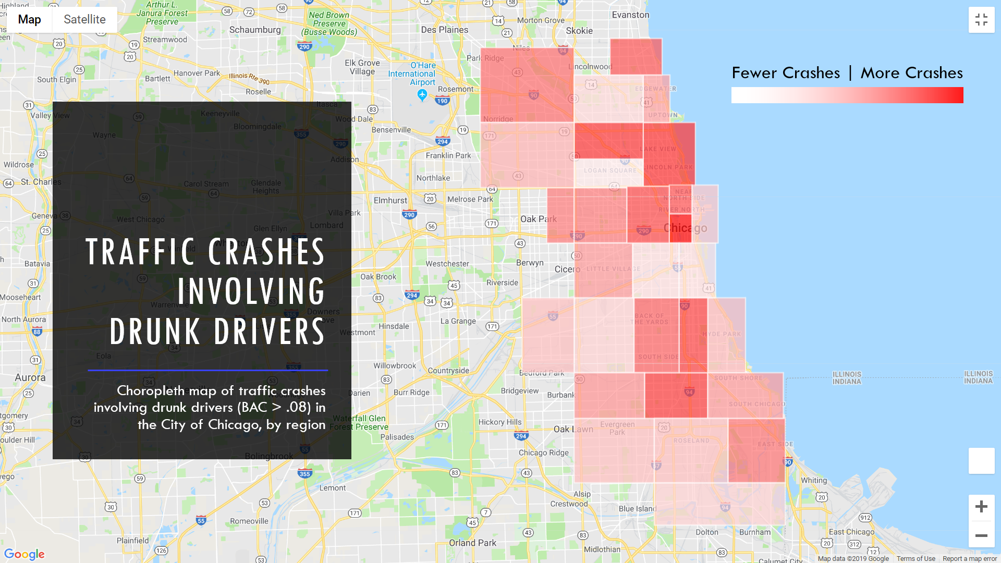

1. What is the most common cause of crashes? What age driver is most likely to be involved in a crash?

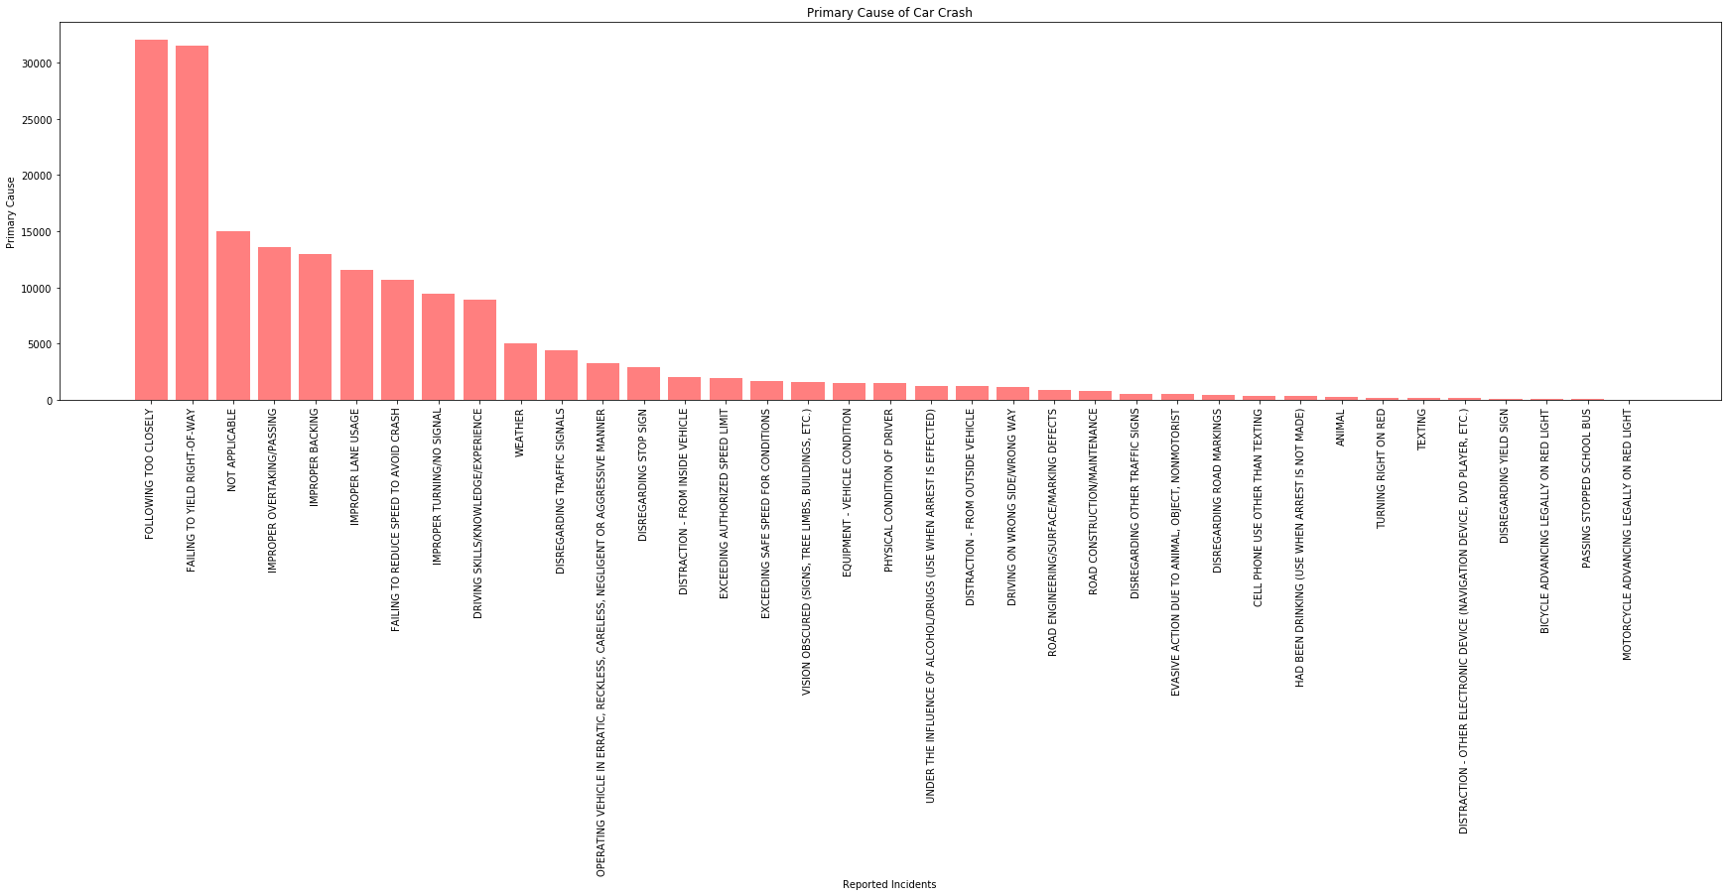

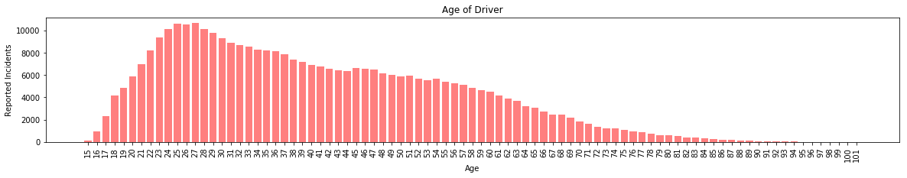

The average age of a driver involved in a crash in Chicago is significantly lower than the average age of all drivers in Illinois.

p = 0.0023588

1. Is there a correlation between cameras and severity of accidents?

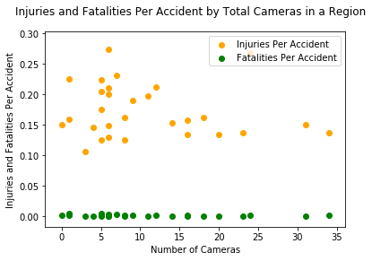

There is poor correlation in both cases. (r for injuries is -.13, r for fatalities is -.25). Overall the rate of injuries is not dependent on the amount of traffic cameras present in a region.

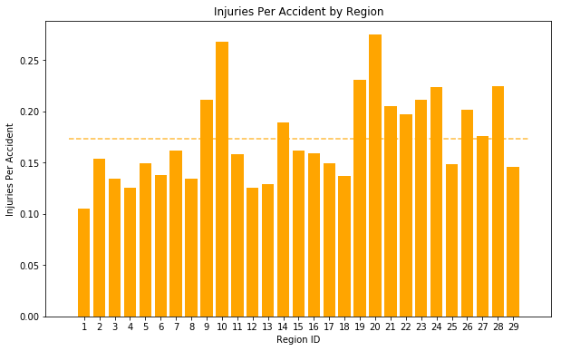

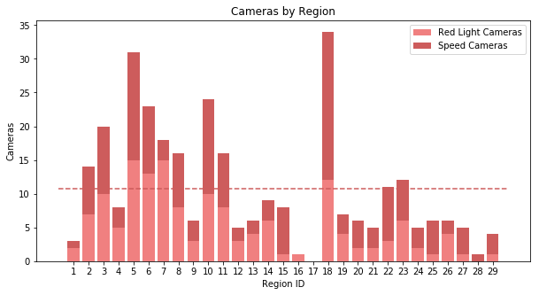

1. Is speeding a main contributor to crashes and in what areas are accidents involving speeding more/less common?

